1.Write a hive query to find the city wise list all the Condos which is not less than ten thousand.

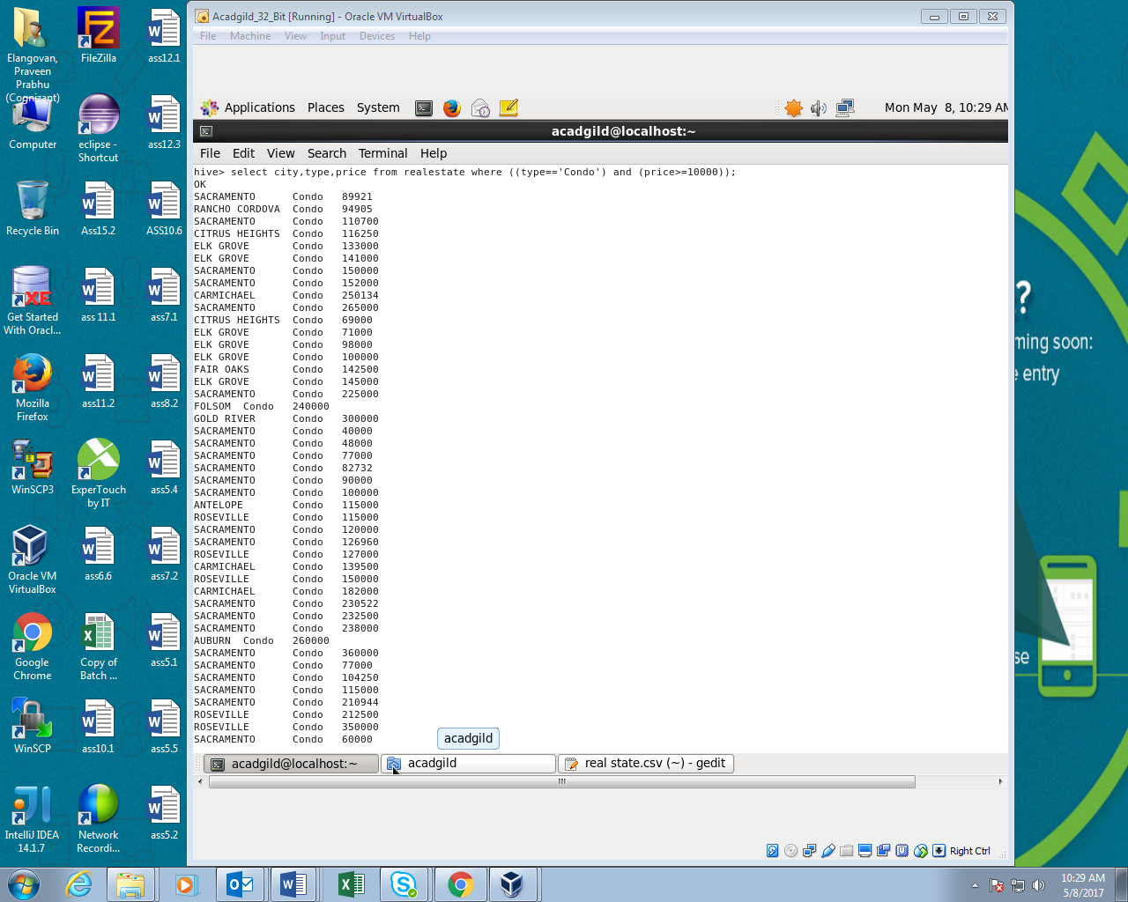

2.Write a hive query to find which is the cheapest Condo in CA. name the city,street and price for the Condo.

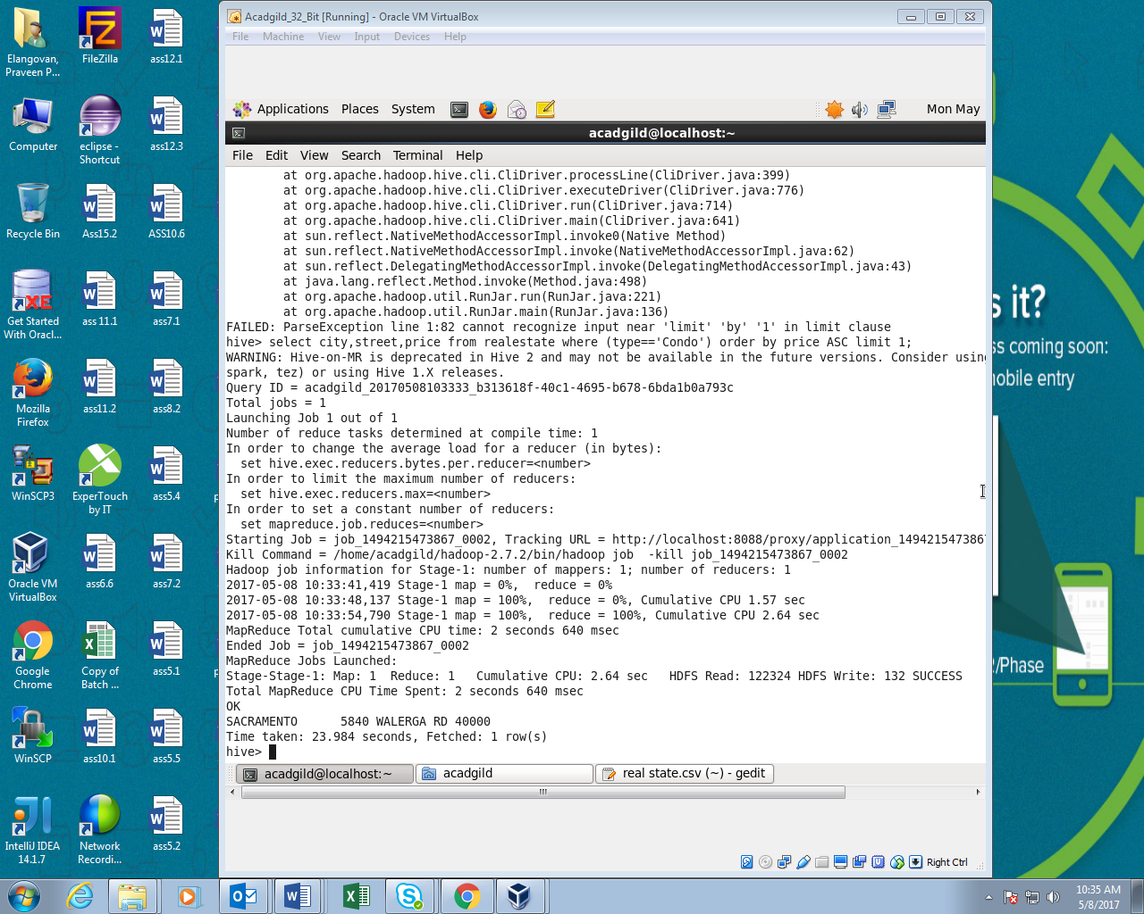

3. Write a hive query to list top 5 residency details which lie in the budget of 60000-120000, an area more than 1450, sold after 17th may, min bedroom 3 and,min bathroom 2.

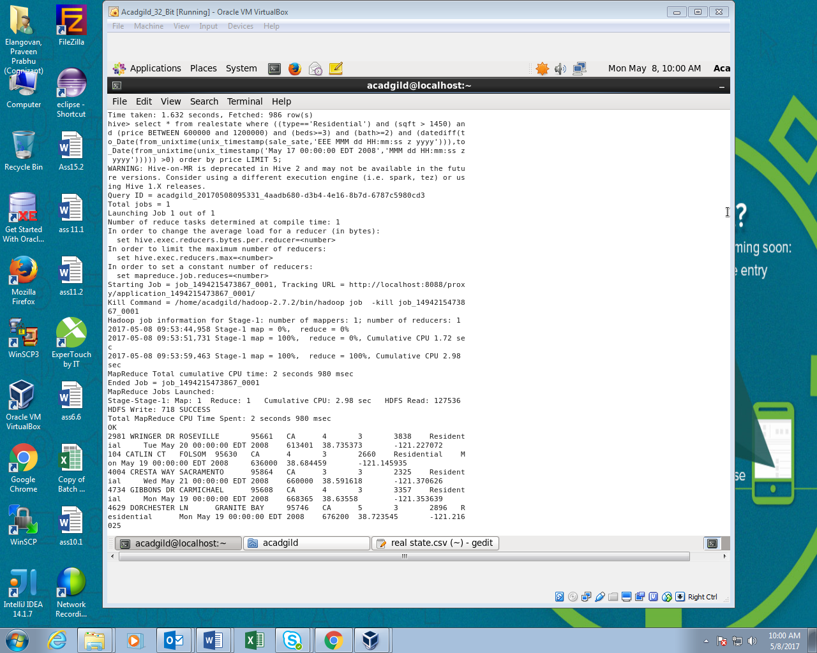

4. Write a hive query to separate list of residential apartments with more than 2 beds. Also include columns in following order City,Baths,Sq_feet,Price,flat_type,Beds respectively.

Since the output is very large I uploaded only few rows.

